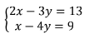
[‘Example 1: Solve the system of linear equations by substitution

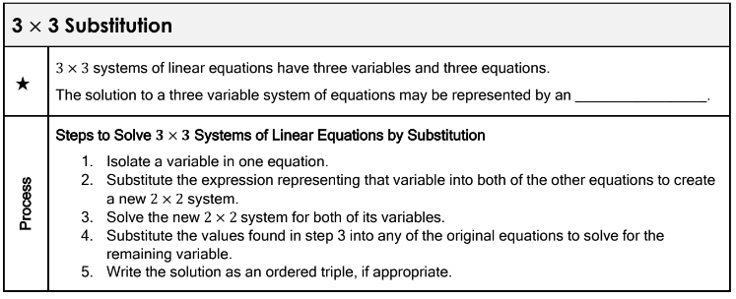
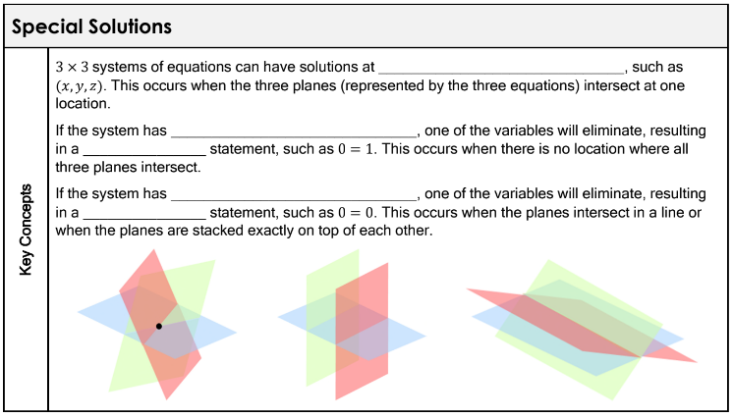
Example 2: Solve the system of linear equations by substitution
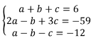

Example 3: Solve the system of linear equations by substitution
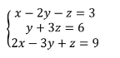

Example 4: Solve the system of linear equations by substitution
